Vignet

**Extro Sink Cock with Swivel Spout – Angular Handle (Wall Mounted)**

**Product Description:**  
Elegant and space-efficient wall-mounted sink cock with a high-arc swivel spout and uniquely contoured angular handle, crafted for precision control and durability in kitchen or utility use.

**5 Key Features (in single line):**  
✅ Stylish angular handle design ✅ 360° swivel spout for flexible use ✅ Wall-mounted to save counter space ✅ Mirror chrome finish for premium look ✅ Heavy-duty brass for leakproof durability

**Product Specifications:**  
• Brand: Extro  
• Product Type: Sink Cock with Swivel Spout  
• Installation: Wall Mounted  
• Spout: High-arch 360° Rotatable  
• Handle Design: Angular Lever  
• Body Material: Pure Brass  
• Finish: Chrome Plated (CP)  
• Operating Mechanism: Quarter Turn Ceramic Cartridge  
• Inlet Size: 15mm BSP Standard  
• Suitable For: Kitchen Sink / Utility Basin  
• Warranty: 5 Years Manufacturer Warranty

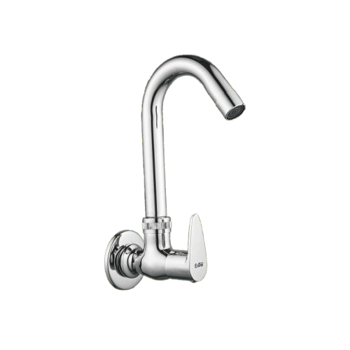

**Extro Bib Cock – Angular Handle (Wall Mounted)**

**Product Description:**  
Compact and durable wall-mounted bib cock with angular lever handle, designed for smooth water flow control in residential and commercial bathrooms or utility spaces.

**Key Features:**  
✅ Angular handle for easy grip and control  
✅ Compact wall-mounted design saves space  
✅ Chrome finish offers corrosion resistance  
✅ Brass body ensures long-lasting durability  
✅ Quarter-turn ceramic disc for smooth operation

**Product Specifications:**  
• **Brand:** Extro  
• **Product Type:** Bib Cock  
• **Installation:** Wall Mounted  
• **Handle Design:** Angular Lever  
• **Body Material:** Pure Brass  
• **Finish:** Chrome Plated (CP)  
• **Spout Type:** Straight Flow  
• **Operating Mechanism:** Quarter Turn Ceramic Cartridge  
• **Inlet Size:** 15mm BSP Standard  
• **Suitable For:** Bathroom / Utility Wash Areas  
• **Warranty:** 5 Years Manufacturer Warranty

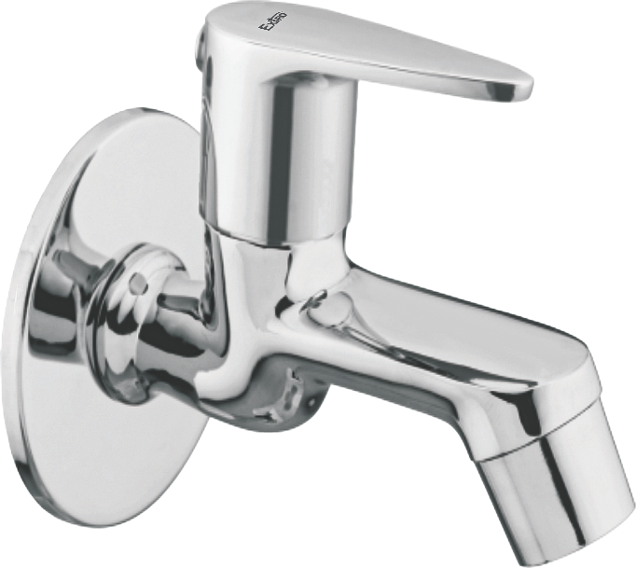

**Extro Long Body Bib Cock – Angular Handle (Wall Mounted)**

**Product Description:**  
Sleek and functional long body bib cock with ergonomic angular handle, ideal for versatile wall-mounted applications in kitchens, bathrooms, or utility areas with extended reach.

**5 Key Features:**  
✅ Extended spout for easy water access  
✅ Stylish angular handle with ergonomic control  
✅ Chrome plated finish for modern aesthetics  
✅ Solid brass construction ensures longevity  
✅ Smooth quarter-turn ceramic operation

**Product Specifications:**  
• **Brand:** Extro  
• **Product Type:** Long Body Bib Cock  
• **Installation:** Wall Mounted  
• **Spout Type:** Extended Reach  
• **Handle Design:** Angular Lever  
• **Body Material:** Pure Brass  
• **Finish:** Chrome Plated (CP)  
• **Operating Mechanism:** Quarter Turn Ceramic Cartridge  
• **Inlet Size:** 15mm BSP Standard  
• **Suitable For:** Bathroom / Kitchen / Utility Use  
• **Warranty:** 5Years Manufacturer Warranty

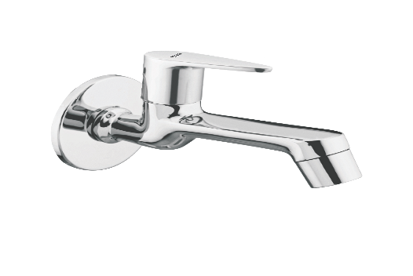

**Extro Angular Stop Cock – Angular Handle (Wall Mounted)**

**Product Description:**  
Compact and sturdy angular stop cock featuring a modern angular lever handle, perfect for regulating water flow to health faucets, geysers, and washing machines.

**5 Key Features:**  
✅ Angular handle for easy grip and control  
✅ Compact wall-mounted design saves space  
✅ Sturdy brass construction for long life  
✅ Smooth chrome finish resists corrosion  
✅ Reliable quarter-turn ceramic cartridge

**Product Specifications:**  
• **Brand:** Extro  
• **Product Type:** Angular Stop Cock  
• **Installation:** Wall Mounted  
• **Handle Design:** Angular Lever  
• **Body Material:** Pure Brass  
• **Finish:** Chrome Plated (CP)  
• **Operating Mechanism:** Quarter Turn Ceramic Cartridge  
• **Inlet Size:** 15mm BSP Standard  
• **Outlet Type:** Threaded for Attachments  
• **Suitable For:** Geysers, Washing Machines, Health Faucets  
• **Warranty:** 5Years Manufacturer Warranty

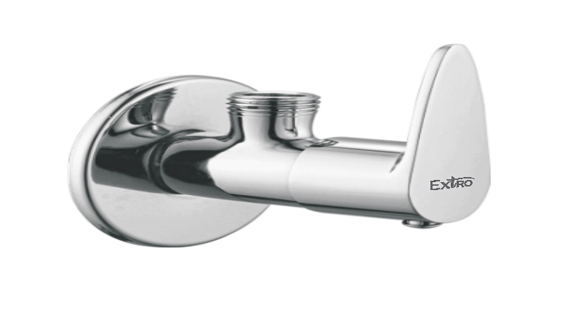

**Extro Concealed Stop Cock – Angular Handle (Built-in)**

**Product Description:**  
High-performance concealed stop cock with a sleek angular lever handle, designed for in-wall installation offering precise control and seamless aesthetics in bathrooms and wet areas.

**5 Key Features:**  
✅ Concealed body for modern minimal look  
✅ Angular handle for easy operation  
✅ Full brass body ensures durability  
✅ Rust-resistant chrome finish  
✅ Smooth quarter-turn ceramic cartridge

**Product Specifications:**  
• **Brand:** Extro  
• **Product Type:** Concealed Stop Cock  
• **Installation:** In-wall / Built-in  
• **Handle Design:** Angular Lever  
• **Body Material:** Pure Brass  
• **Finish:** Chrome Plated (CP)  
• **Operating Mechanism:** Quarter Turn Ceramic Cartridge  
• **Inlet/Outlet Size:** 15mm BSP Standard  
• **Suitable For:** Bathrooms, Washrooms, Geysers, Showers  
• **Warranty:** 5Years Manufacturer Warranty

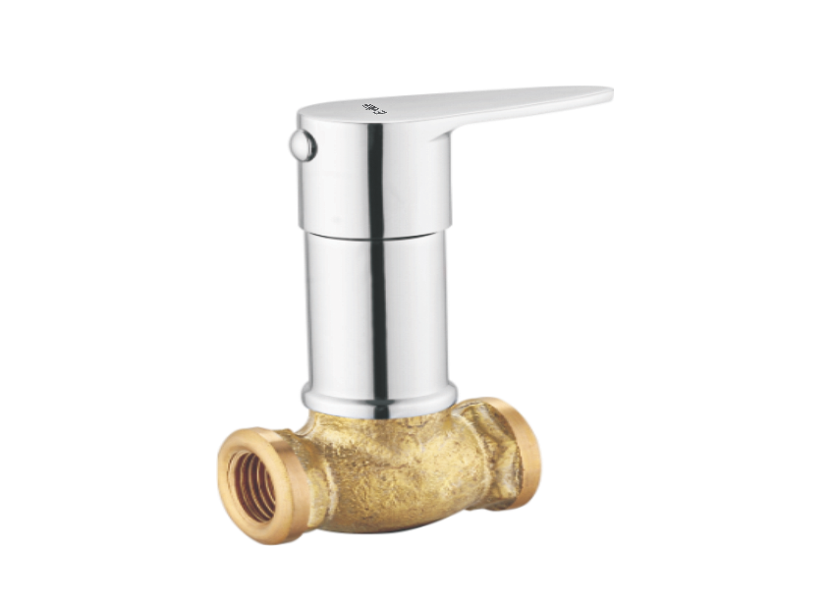

**Extro Pillar Cock – Angular Handle (Table Mounted)**

**Product Description:**  
Modern pillar cock with ergonomic angular lever handle, designed for easy countertop installation, offering smooth water flow and refined aesthetics for wash basins and sinks.

**5 Key Features:**  
✅ Sleek table-mounted pillar design  
✅ Ergonomic angular handle for control  
✅ Solid brass build for long-term reliability  
✅ Premium chrome finish resists rust  
✅ Smooth quarter-turn ceramic cartridge

**Product Specifications:**  
• **Brand:** Extro  
• **Product Type:** Pillar Cock  
• **Installation:** Table Mounted  
• **Handle Design:** Angular Lever  
• **Body Material:** Pure Brass  
• **Finish:** Chrome Plated (CP)  
• **Operating Mechanism:** Quarter Turn Ceramic Cartridge  
• **Inlet Size:** 15mm BSP Standard  
• **Suitable For:** Wash Basins, Countertop Sinks  
• **Warranty:** 5Years Manufacturer Warranty

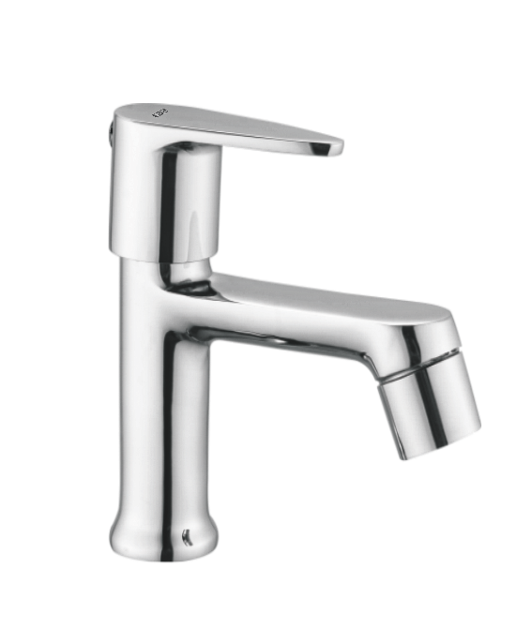

**Extro 2-in-1 Bib Cock – Angular Handle (Wall Mounted)**

**Product Description:**  
Versatile 2-in-1 bib cock with dual water outlet functionality and sleek angular handle, ideal for use with both bucket filling and connection to appliances like washing machines or health faucets.

**5 Key Features:**  
✅ Dual outlet design for multi-purpose use  
✅ Sleek angular handle for better grip  
✅ Durable brass body with leakproof design  
✅ Corrosion-resistant chrome finish  
✅ Easy wall-mounted installation

**Product Specifications:**  
• **Brand:** Extro  
• **Product Type:** 2-in-1 Bib Cock  
• **Installation:** Wall Mounted  
• **Handle Design:** Angular Lever  
• **Body Material:** Pure Brass  
• **Finish:** Chrome Plated (CP)  
• **Operating Mechanism:** Quarter Turn Ceramic Cartridge  
• **Inlet Size:** 15mm BSP Standard  
• **Outlet Type:** Dual – Nozzle + Threaded Attachment  
• **Suitable For:** Bathrooms, Washing Machines, Utility Areas  
• **Warranty:** 5 Years Manufacturer Warranty

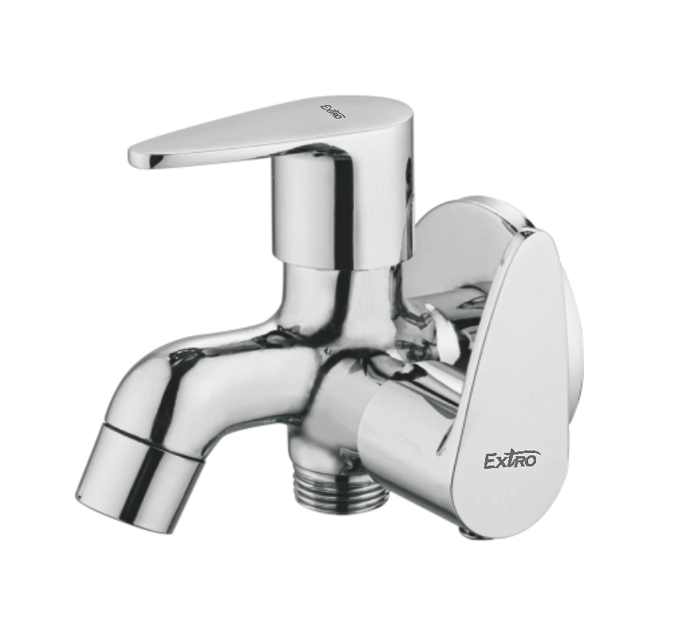

**Extro 2-in-1 Angle Cock – Angular Handle (Wall Mounted)**

**Product Description:**  
Multi-functional 2-in-1 angle cock with an angular handle, designed for dual water outlet requirements such as connection to flush tanks, geysers, or appliances, ensuring both style and utility.

**5 Key Features:**  
✅ Dual outlet design for versatile connections  
✅ Elegant angular handle for precise control  
✅ Premium-grade brass body for durability  
✅ Mirror-finish chrome plating resists corrosion  
✅ Quarter-turn ceramic valve ensures long-lasting use

**Product Specifications:**  
• **Brand:** Extro  
• **Product Type:** 2-in-1 Angle Cock  
• **Installation:** Wall Mounted  
• **Handle Design:** Angular Lever  
• **Body Material:** Pure Brass  
• **Finish:** Chrome Plated (CP)  
• **Operating Mechanism:** Quarter Turn Ceramic Cartridge  
• **Inlet Size:** 15mm BSP Standard  
• **Outlet Type:** Dual – Threaded for Appliance & Open Flow  
• **Suitable For:** Geysers, Flush Tanks, Washing Machines  
• **Warranty:** 5 Years Manufacturer Warranty

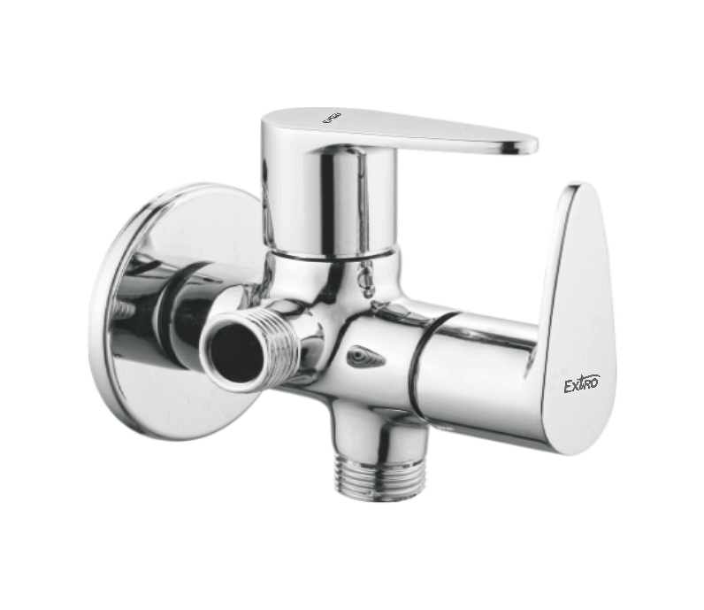

**Extro Sink Cock with Swivel Spout – Angular Handle (Deck Mounted)**

**Product Description:**  
Sleek and modern deck-mounted sink cock featuring a high-rise swivel spout and an ergonomically styled angular lever, perfect for countertop kitchen sinks or utility basins.

**5 Key Features:**  
✅ Stylish tall gooseneck swivel spout for wide reach  
✅ Deck-mounted for easy sink-top installation  
✅ Elegant angular handle for smooth operation  
✅ Durable brass body with anti-rust chrome finish  
✅ Quarter-turn ceramic cartridge for reliable performance

**Product Specifications:**  
• **Brand:** Extro  
• **Product Type:** Sink Cock with Swivel Spout  
• **Installation:** Deck Mounted  
• **Spout:** High-Arch 360° Rotatable  
• **Handle Design:** Angular Lever  
• **Body Material:** Pure Brass  
• **Finish:** Chrome Plated (CP)  
• **Operating Mechanism:** Quarter Turn Ceramic Cartridge  
• **Inlet Size:** 15mm BSP Standard  
• **Suitable For:** Kitchen Countertop Sink / Utility Basin  
• **Warranty:** 5Years Manufacturer Warranty

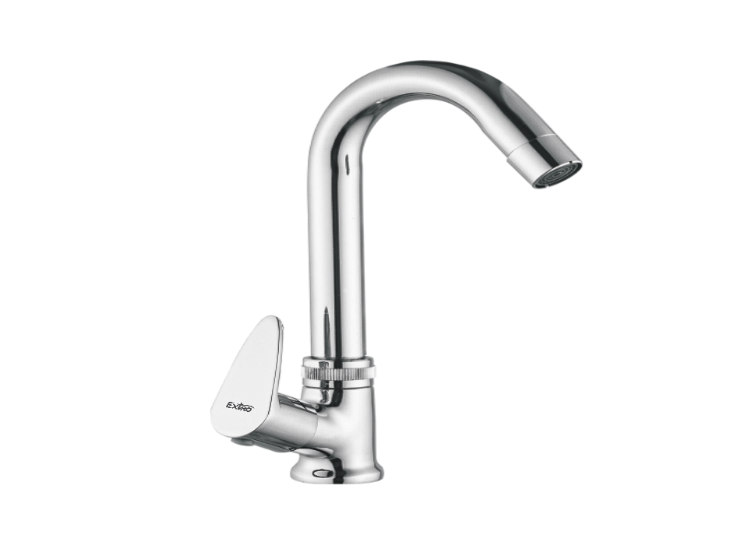

**Extro Sink Cock with Swivel Spout – Angular Handle (Wall Mounted)**

**Product Description:**  
Compact and elegant wall-mounted sink cock with a high-rise swivel spout and modern angular handle, designed for versatility and long-lasting performance in kitchen or utility areas.

**Key Features:**  
✅ Tall gooseneck swivel spout for full sink access  
✅ Wall-mounted design for cleaner countertops  
✅ Contemporary angular handle for ergonomic use  
✅ Rust-resistant mirror chrome finish  
✅ Solid brass body with ceramic cartridge durability

**Product Specifications:**  
• **Brand:** Extro  
• **Product Type:** Sink Cock with Swivel Spout  
• **Installation:** Wall Mounted  
• **Spout:** High-Arch 360° Rotatable  
• **Handle Design:** Angular Lever  
• **Body Material:** Pure Brass  
• **Finish:** Chrome Plated (CP)  
• **Operating Mechanism:** Quarter Turn Ceramic Cartridge  
• **Inlet Size:** 15mm BSP Standard  
• **Suitable For:** Kitchen Sink / Utility Basin  
• **Warranty:** 5Years Manufacturer Warranty

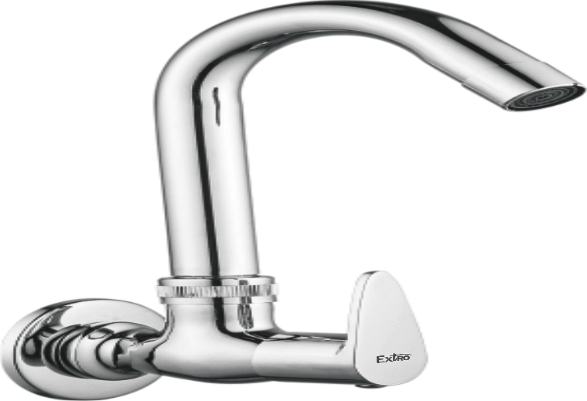

**Extro Swan Neck Tap – Dual Angular Handle (Deck Mounted)**

**Product Description:**  
Stylish dual-handle swan neck tap with a tall curved spout, designed for precision mixing of hot and cold water. Ideal for modern kitchen or basin installations where both aesthetics and control matter.

**Key Features:**  
✅ Dual-handle system for hot & cold flow control  
✅ Elegant swan neck design for high-arc clearance  
✅ Deck-mounted for countertop installation  
✅ Mirror chrome finish for a luxury appearance  
✅ Solid brass body with smooth quarter-turn action

**Product Specifications:**  
• **Brand:** Extro  
• **Product Type:** Swan Neck Mixer Tap  
• **Installation:** Deck Mounted  
• **Spout:** Tall Curved Fixed Spout  
• **Handle Design:** Dual Angular Lever  
• **Body Material:** Pure Brass  
• **Finish:** Chrome Plated (CP)  
• **Operating Mechanism:** Quarter Turn Ceramic Cartridges  
• **Inlet Size:** 15mm BSP Dual Inlet  
• **Suitable For:** Kitchen Sink / Wash Basin with Hot & Cold Water  
• **Warranty:** 5Years Manufacturer Warranty

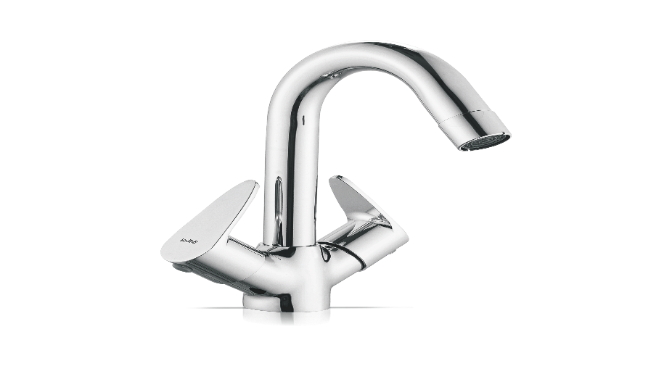

**Extro Swan Neck Wall Mixer – Dual Angular Handle (Wall Mounted)**

**Product Description:**  
Premium wall-mounted swan neck wall mixer with dual handles for hot and cold water control. Designed for kitchens or wash areas requiring elevated water flow and elegant aesthetics.

**Key Features:**  
✅ Dual-handle operation for hot & cold control  
✅ High-arc swan neck spout for better clearance  
✅ Wall-mounted to save counter space  
✅ Elegant chrome finish for lasting shine  
✅ Brass body ensures corrosion resistance and durability

**Product Specifications:**  
• **Brand:** Extro  
• **Product Type:** Swan Neck Wall Mixer  
• **Installation:** Wall Mounted  
• **Spout:** Fixed Swan Neck  
• **Handle Design:** Dual Angular Lever  
• **Body Material:** Pure Brass  
• **Finish:** Chrome Plated (CP)  
• **Operating Mechanism:** Quarter Turn Ceramic Cartridge  
• **Inlet Size:** 15mm BSP Dual Inlet  
• **Suitable For:** Kitchen Sinks, Wash Areas  
• **Warranty:** 5 Years Manufacturer Warranty

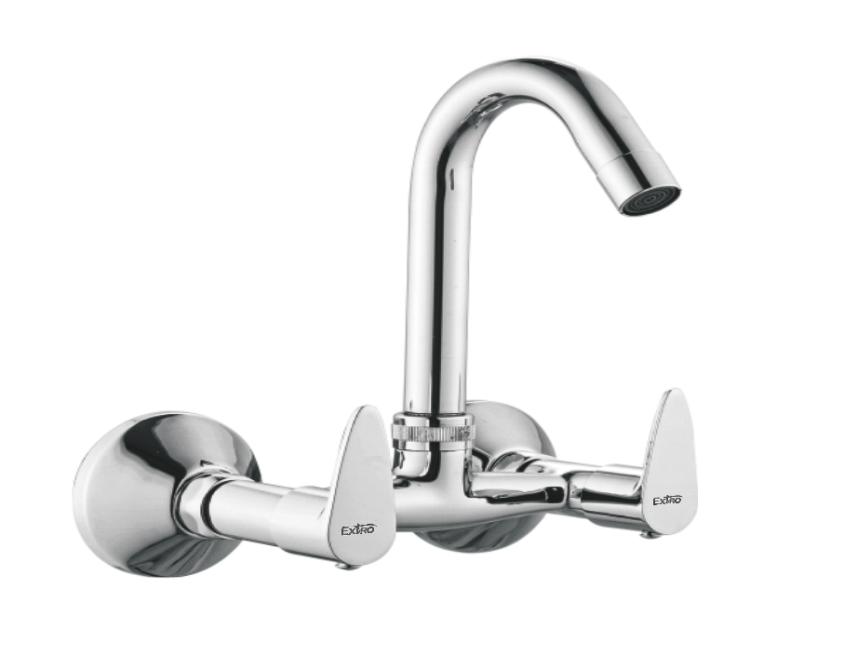

**Extro Wall Mixer with Overhead and Spout – Angular Handle (Wall Mounted)**

**Product Description:**  
High-performance wall mixer with overhead shower provision and lower spout, designed for bathrooms needing combined control of shower and tap water with smooth switching and stylish control.

**Key Features:**  
✅ Dual-handle for hot & cold water control  
✅ Provision for overhead shower and lower tap  
✅ Smooth diverter knob for shower/tap switch  
✅ Stylish angular handles with ergonomic grip  
✅ Durable chrome finish with brass body construction

**Product Specifications:**  
• **Brand:** Extro  
• **Product Type:** Wall Mixer with Overhead and Spout  
• **Installation:** Wall Mounted  
• **Spout Type:** Downward Spout with Shower Diverter  
• **Handle Design:** Dual Angular Lever  
• **Body Material:** Pure Brass  
• **Finish:** Chrome Plated (CP)  
• **Operating Mechanism:** Quarter Turn Ceramic Cartridge  
• **Inlet Size:** 15mm BSP Dual Inlet  
• **Shower Outlet:** Standard Shower Arm Compatible  
• **Suitable For:** Bathrooms (Tap + Overhead Shower Control)  
• **Warranty:** 5 Years Manufacturer Warranty

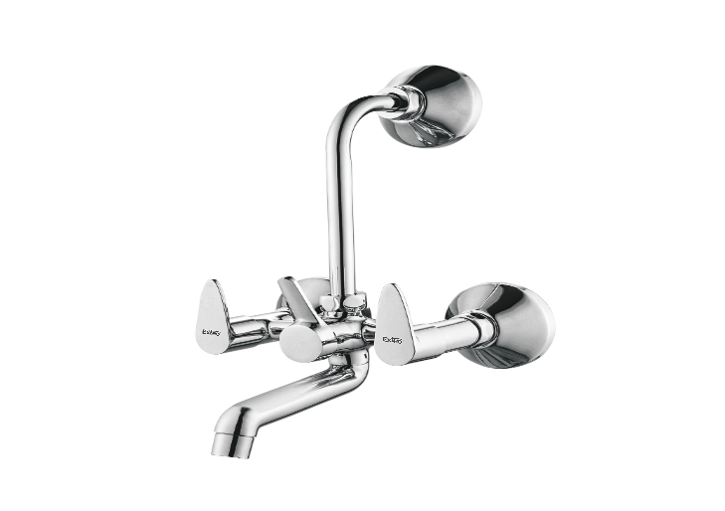

**Extro Wall Mixer with Crutch & Bend Pipe – Angular Handle (Wall Mounted)**

**Product Description:**  
Elegant and versatile wall mixer featuring a crutch design and bend pipe, ideal for combined tap and overhead shower functionality with a sleek, dual-handle operation.

**Key Features:**  
✅ Dual lever handles for hot and cold water control  
✅ Includes bend pipe for overhead shower connection  
✅ Smooth diverter knob for easy switching  
✅ Durable chrome-plated brass body for longevity  
✅ Stylish and ergonomic angular handle design

**Product Specifications:**  
• **Brand:** Extro  
• **Product Type:** Wall Mixer with Crutch & Bend Pipe  
• **Installation:** Wall Mounted  
• **Handle Design:** Dual Angular Lever  
• **Body Material:** Pure Brass  
• **Finish:** Chrome Plated (CP)  
• **Spout Type:** Lower Spout with Diverter  
• **Shower Connection:** Bend Pipe for Overhead Shower  
• **Operating Mechanism:** Quarter Turn Ceramic Cartridge  
• **Inlet Size:** 15mm BSP Standard  
• **Suitable For:** Bathrooms (Mixing Tap + Shower Control)  
• **Warranty:** 5 Years Manufacturer Warranty

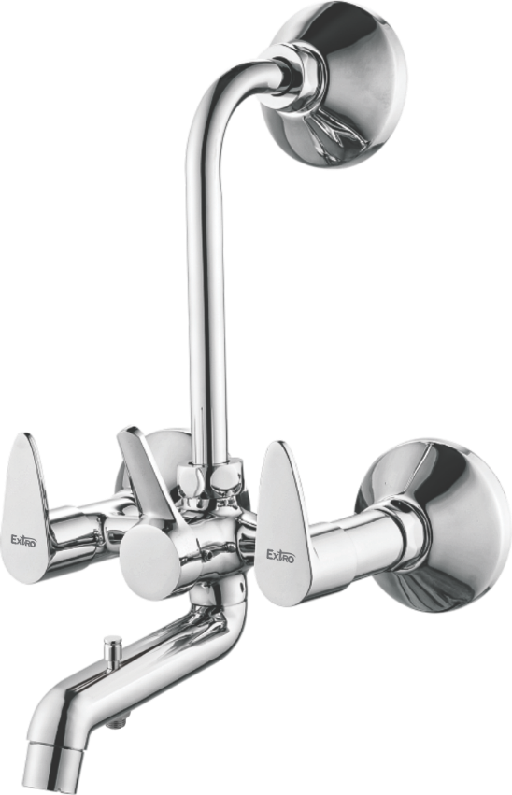

**Extro Sink Tap with Wall Flange – Angular Handle (Wall Mounted)**

**Product Description:**  
Premium wall-mounted sink tap with long round spout and ergonomic angular handle, designed for durability and convenient single-handle operation in kitchens or utility areas.

**Key Features:**  
✅ Wall mounted with extended round spout for reach  
✅ Sleek angular handle for effortless control  
✅ Chrome-plated brass for superior finish and corrosion resistance  
✅ Smooth quarter turn ceramic disc operation  
✅ Ideal for kitchen or utility wall installations

**Product Specifications:**  
• **Brand:** Extro  
• **Product Type:** Wall Mounted Sink Tap  
• **Installation:** Wall Mounted  
• **Handle Design:** Single Angular Lever  
• **Material:** High-Grade Brass  
• **Finish:** Chrome Plated (CP)  
• **Spout Type:** Long Round Swivel Spout  
• **Cartridge:** Quarter Turn Ceramic Disc  
• **Inlet Connection:** 15mm BSP  
• **Application:** Kitchen Sink, Utility Basin  
• **Warranty:** 5 Years Manufacturer Warranty

